**Eclipse Plugin for Intellisense Support in Scripting**

**Step 1 : Download the plugin**

You will need to save the file to your computer. For example save it to C:\TradeCard\AppXpressPlugins\appxScriptingPlugin.zip. YOU DO NOT NEED TO UNZIP IT.

**Step 2 : Install the plugin in eclipse**

Open Eclipse.

Select "Help" - "Install New Software..."

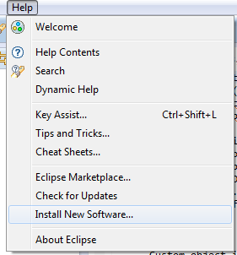

Click on the "Add..." button, next to “Work with”.

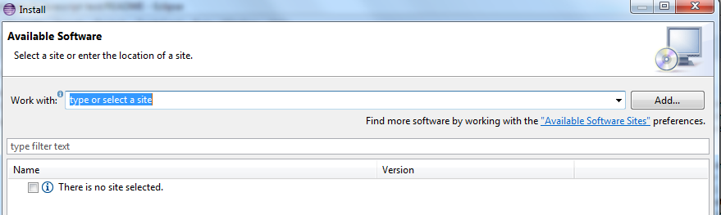

On the right hand side, select "Archive..."

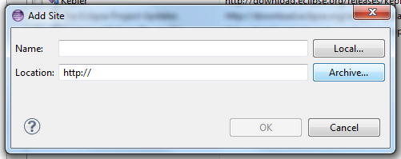

Navigate and choose "appxScriptingPlugin.zip" – click Open.

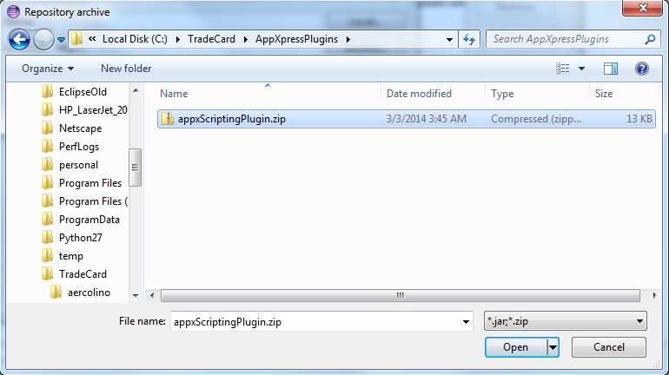

Back on the "Add Site" window - enter Name - "AppX Scripting Plugin"

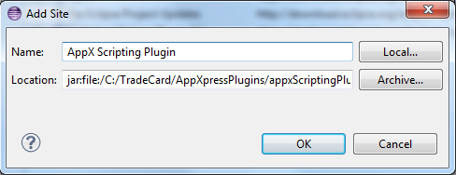

Click “OK”.

Back onto the “Install” window - "Available Software", for "Work with;" "AppX Scripting Plugin" will be selected.

In the selection box - you should now see "AppXpressScripting” - select it and click on “Next”.

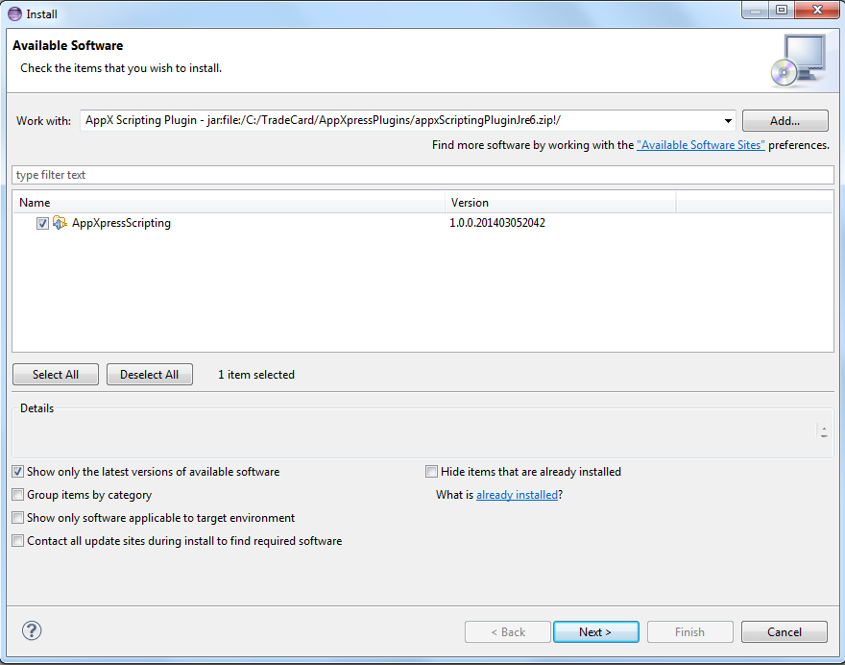

On "Install Details" screen, click “Next”. This plugin requires the Javascript Development Tools plugin.

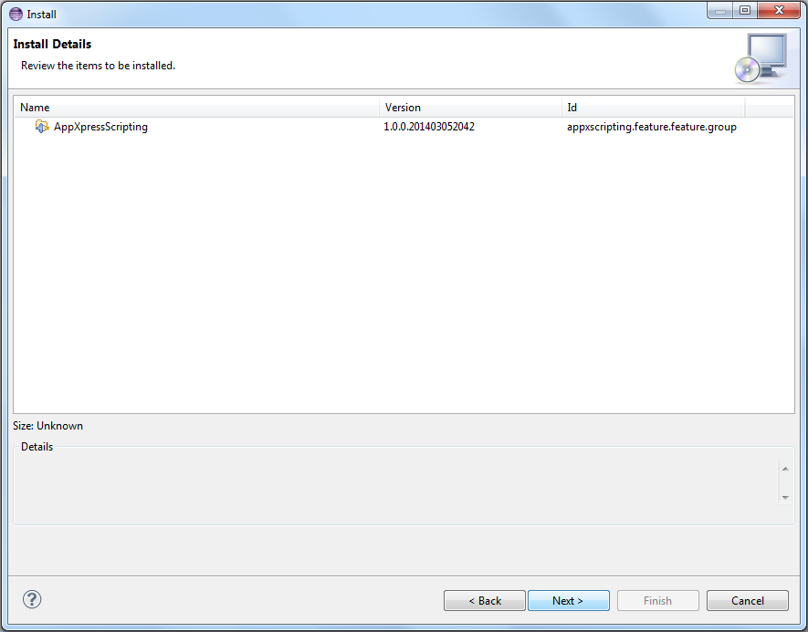

On "Review Licenses" screen, select the “I accept the terms...” and click “Finish”.

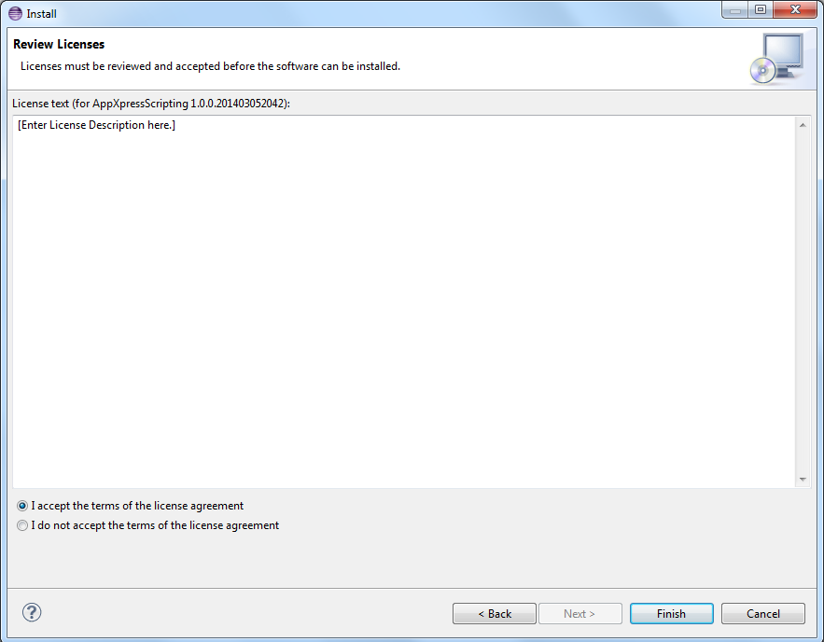

You will get a security warning - click “OK”.

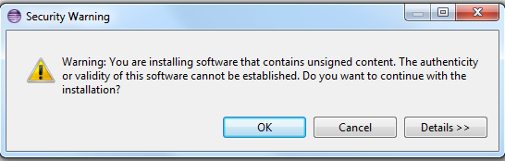

You will then get a popup prompting you to restart. Select to restart now.

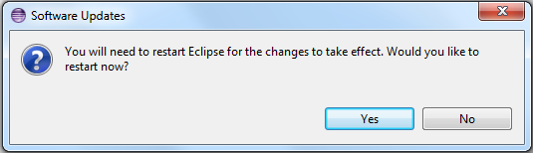

It is now installed.

**Step 3: Use the plugin to setup a new project**

To create a new project. Select "File" menu - "New” - "Project..."

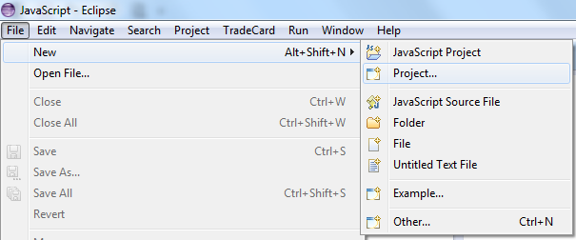

You will be prompted to "Select a wizard". Select "AppXpress Wizards" folder and select "Platform Module Scripting Project" and click "Next".

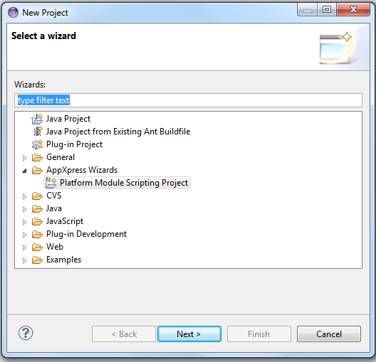

Give your Project a name and click "Next"

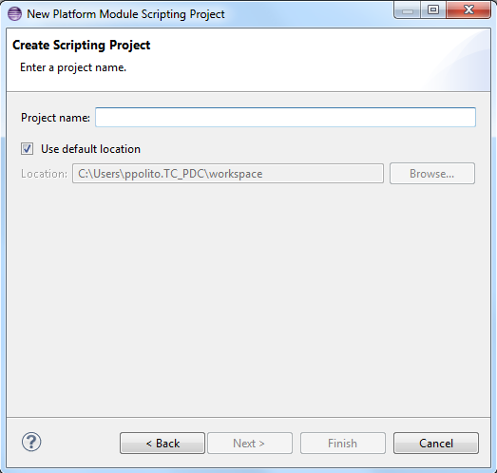

In the next step enter your AppXpress connection details

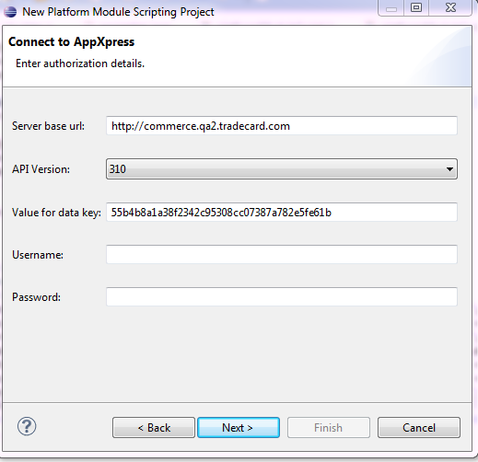

In the final page select the object you want to write the script for. The default value is ‘orderdetail’. Also select the support objects you want to call inside your script. Then click on ‘Finish’.

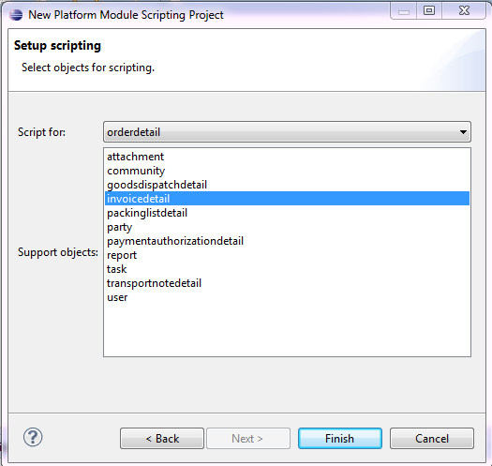

Now an AppXpress Scripting project would have been generated in your workspace. If you are not already in the javascript perspective you will be prompted to switch to it.

Now the ‘platformModuleScript.js’ file will have generated. Edit this script as required and upload it to your platform module.

